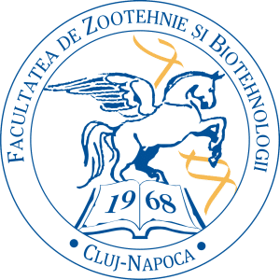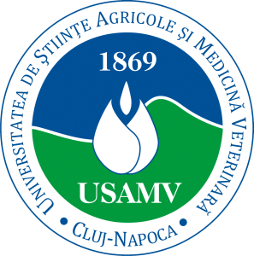

**“The power of human-animal interactions in times of crisis”,**

**7-8 September 2024**

**Cluj-Napoca, Romania**

**IAHAIO** and the **University of Agricultural Science and Veterinary Medicine in Cluj Napoca** (USAMV Cluj-Napoca) co-hosted an **in-person** conference on 7-8 September: **The power of human-animal interactions in times of crisis**. The conference took place at the University of Agricultural Science and Veterinary Medicine, located in Cluj-Napoca, which is a vibrant city in the centre of Transylvania, Romania. USAMV Cluj-Napoca is one of the top Universities in Romania in the areas of research and education in animal sciences. The University offers attractive international study programs in animal behaviour, animal welfare and human-animal interactions.

Over 110 delegates from 24 different countries attended the conference. Keynote speakers included:

Alina Rusu: Education, research and practice in the field of human-animal interaction in Romania – challenges and opportunities

Rebecca Davis: Self-Care for Animal-Oriented Professionals: Lessons from Social Work

Ovidiu Ruso: Twenty years of animal rescue and welfare in Romania

Kersten Uvnas Moberg: An overview of the oxytocin research in human-animal interactions

Rise VanFleet: Animal- Assisted Services for emotional crises and traumatic situations: A careful look at animal perspectives and safeguards during intense interactions

There were also over 25 oral presentations, as well as poster presentations. Four interactive workshops also took place. **You can download the Abstract book here.**